**Name: Abinash Satapathy**

**Reg. no.: 16BCE0081**

**Slot: L33 + L34**

**Subject: Java Programming (CSE1007) Lab**

**Experiment 1**

1. Read the radius and print the area of a circle

import java.util.*;

class q1

{

public static void main(String args[])

{

Scanner obj = new Scanner(System.in);

System.out.println("Enter the radius of the circle");

int r = obj.nextInt();

double area = 3.14 * r * r;

System.out.println("Area = " + area);

}

}

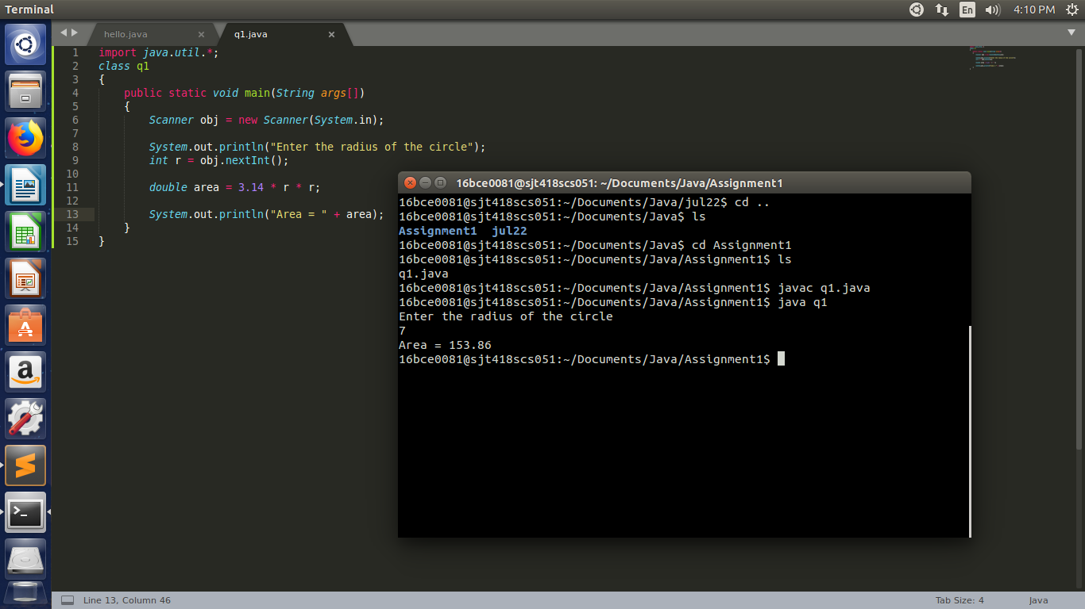

1. Read the number and check whether it is divisible by 3 and 5.

import java.util.*;

class q2

{

public static void main(String args[])

{

Scanner obj = new Scanner(System.in);

System.out.println("Enter a number for divisibility check");

int n = obj.nextInt();

if((n%5==0) && (n%3==0))

System.out.println("Number is divisibile by both 3 and 5");

else

System.out.println("Number is not divisibile by both 3 and 5");

}

}

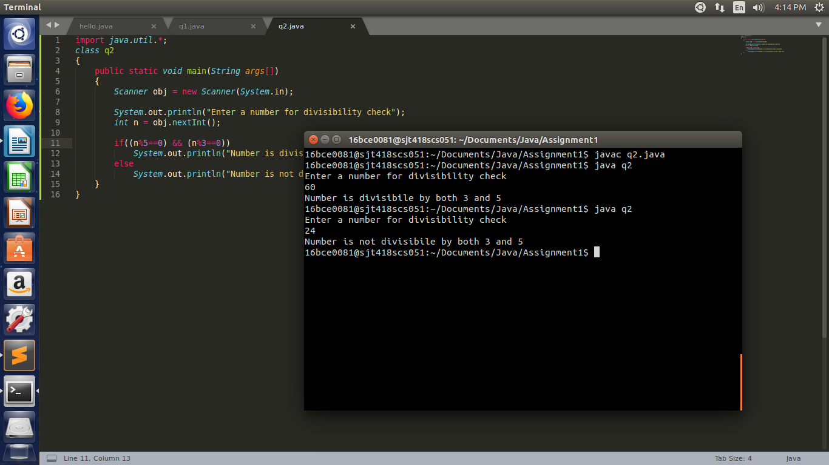

1. Display Subject Name based on room number. If the user enters 604 then display Java Programming, If the user enters 605 then display Python programming for any other input display Invalid input to the user

import java.util.*;

class q3

{

public static void main(String args[])

{

Scanner obj = new Scanner(System.in);

System.out.println("Enter 604 for Java Programming");

System.out.println("Enter 605 for Python programming");

int ch = obj.nextInt();

switch(ch)

{

case 604:

System.out.println("Java Programming");

break;

case 605:

System.out.println("Python Programming");

break;

default:

System.out.println("Wrong choice");

}

}

}

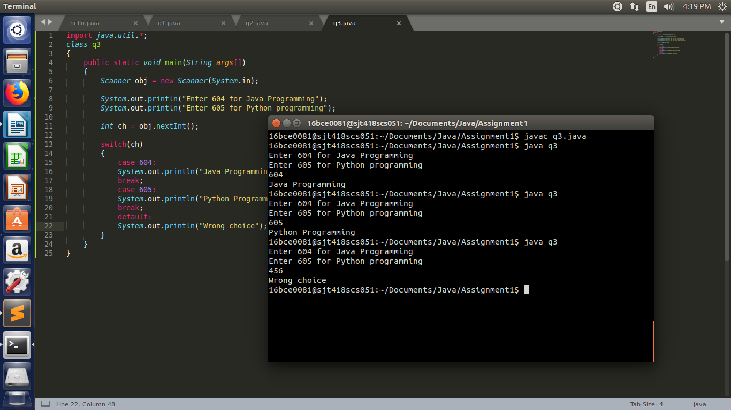

1. Print the sum of first n numbers. If n is 3 then print the sum of 1+2+3 to the user. Get n from the user.

import java.util.*;

class q4

{

public static void main(String args[])

{

Scanner obj = new Scanner(System.in);

System.out.println("Enter the number of terms");

int n = obj.nextInt();

int i, s=0;

for(i=1;i<=n;i++)

s = s + i;

System.out.println("Sum of " + n + " terms = " + s);

}

}

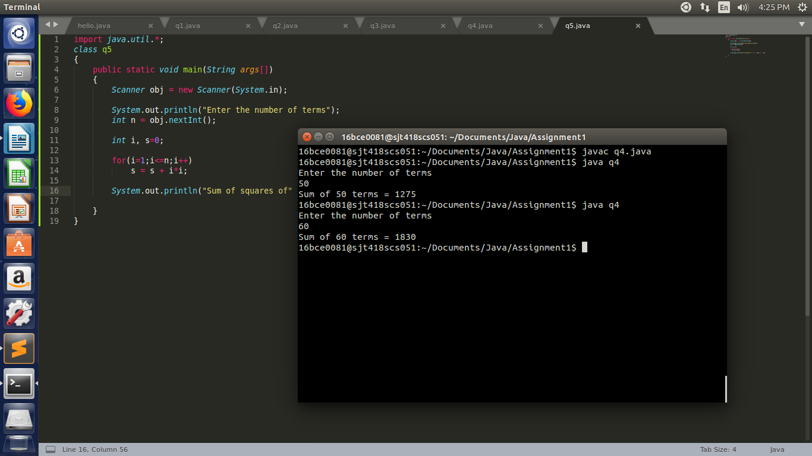

1. Print the sum of the series 12+22+32 up to n terms

import java.util.*;

class q5

{

public static void main(String args[])

{

Scanner obj = new Scanner(System.in);

System.out.println("Enter the number of terms");

int n = obj.nextInt();

int i, s=0;

for(i=1;i<=n;i++)

s = s + i*i;

System.out.println("Sum of squares of" + n + " terms = " + s);

}

}

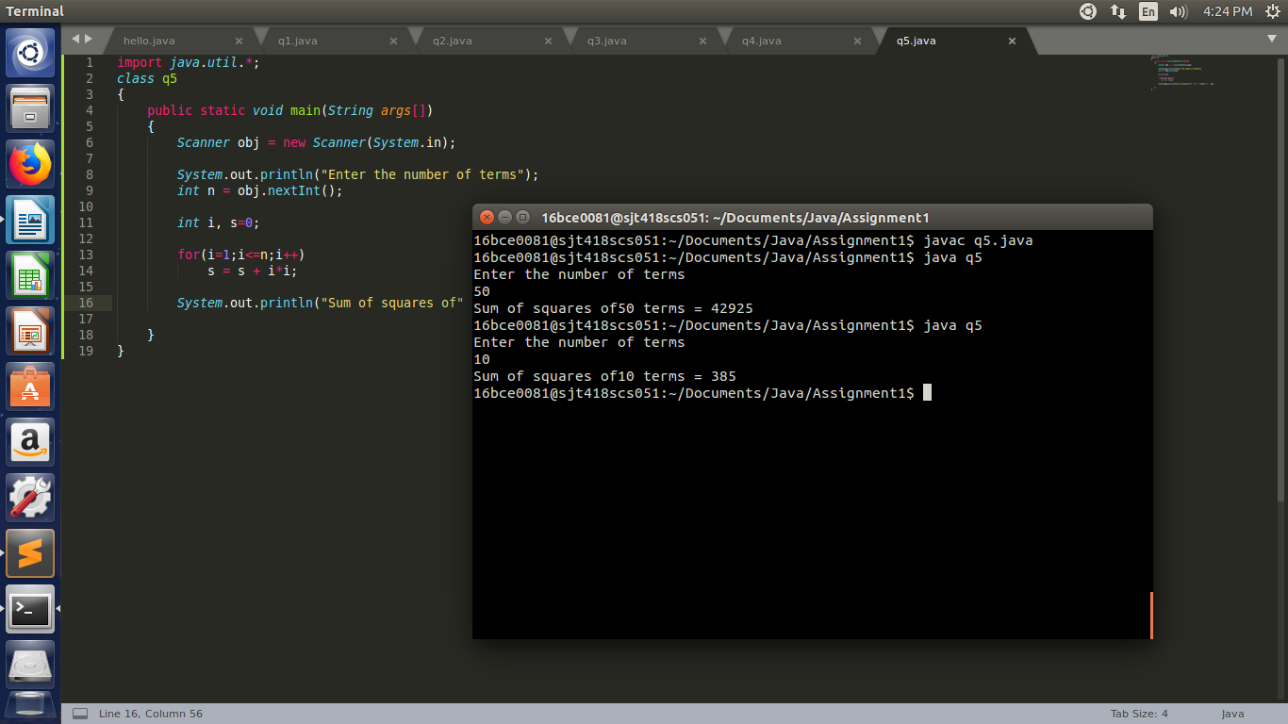

1. Print the multiplication table by getting the n from the user.

import java.util.*;

class q6

{

public static void main(String args[])

{

Scanner obj = new Scanner(System.in);

System.out.println("Enter the Number whose table is to be displayed");

int n = obj.nextInt();

int i;

for(i=1;i<=10;i++)

{

System.out.println(i + " x " + n + " = " + (i*n));

System.out.println();

}

}

}

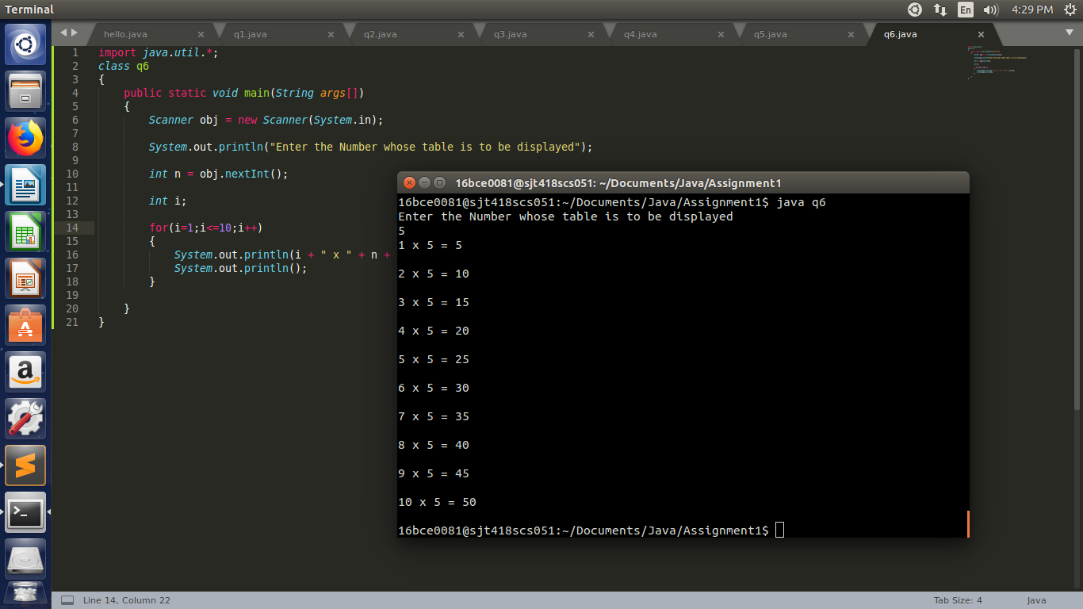

1. Provide the option of adding two numbers to the user until the user wants to exit.

import java.util.*;

class q7

{

public static void main(String args[])

{

Scanner obj = new Scanner(System.in);

int ch = 1;

int a, b;

while(ch!=0)

{

System.out.println("Enter 2 numbers to add.");

a = obj.nextInt();

b = obj.nextInt();

System.out.println("Sum of "+a+" and "+b+" = "+ (a+b));

System.out.println();

System.out.println("Enter 0 to exit");

ch = obj.nextInt();

}

}

}

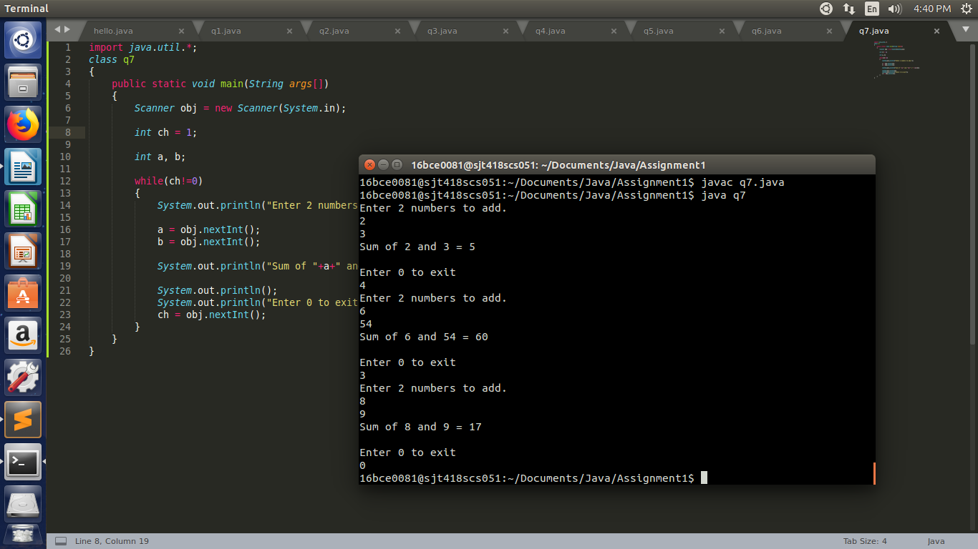

1. (a)

*

**

***

****

import java.util.*;

class q8_1

{

public static void main(String args[])

{

Scanner obj = new Scanner(System.in);

int i, j;

for(i=1;i<=4;i++)

{

for(j=1;j<=i;j++)

System.out.print("* ");

System.out.println("\n");

}

}

}

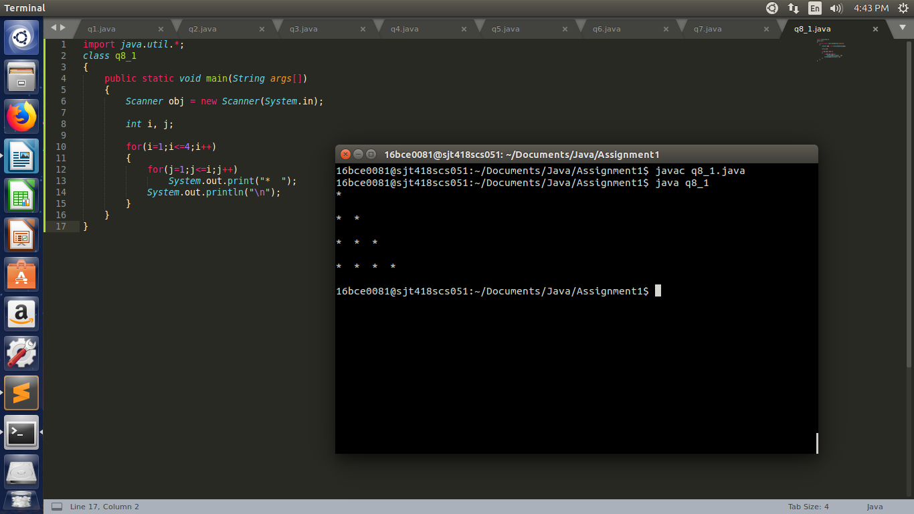

(b)

1234

123

12

1

import java.util.*;

class q8_2

{

public static void main(String args[])

{

Scanner obj = new Scanner(System.in);

int i, j;

for(i=4;i>=1;i--)

{

for(j=1;j<=i;j++)

System.out.print(j+" ");

System.out.println("\n");

}

}

}

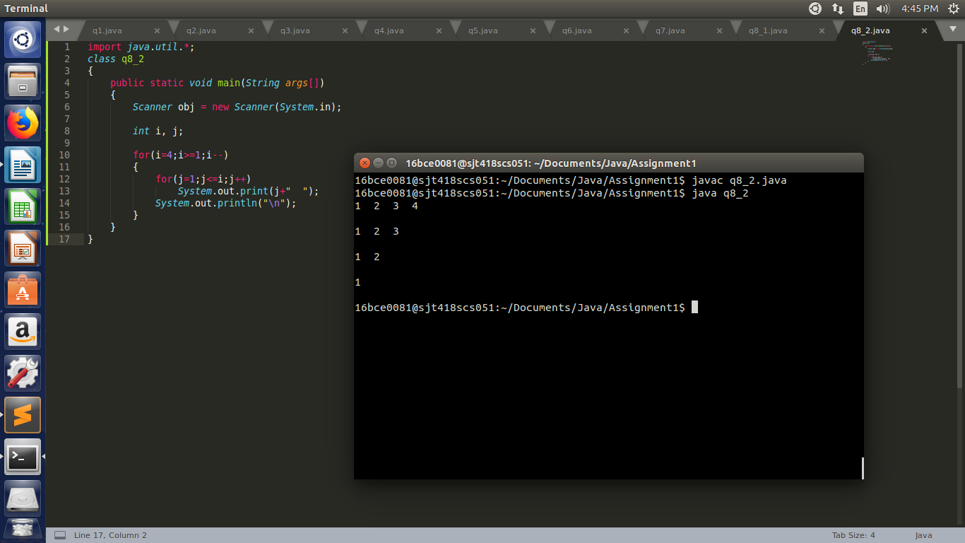

(c)

1

12

123

1234

1234

123

12

1

import java.util.*;

class q8_3

{

public static void main(String args[])

{

Scanner obj = new Scanner(System.in);

int i, j;

for(i=1;i<=4;i++)

{

for(j=1;j<=i;j++)

System.out.print(j+" ");

System.out.println("\n");

}

for(i=4;i>=1;i--)

{

for(j=1;j<=i;j++)

System.out.print(j+" ");

System.out.println("\n");

}

}

}

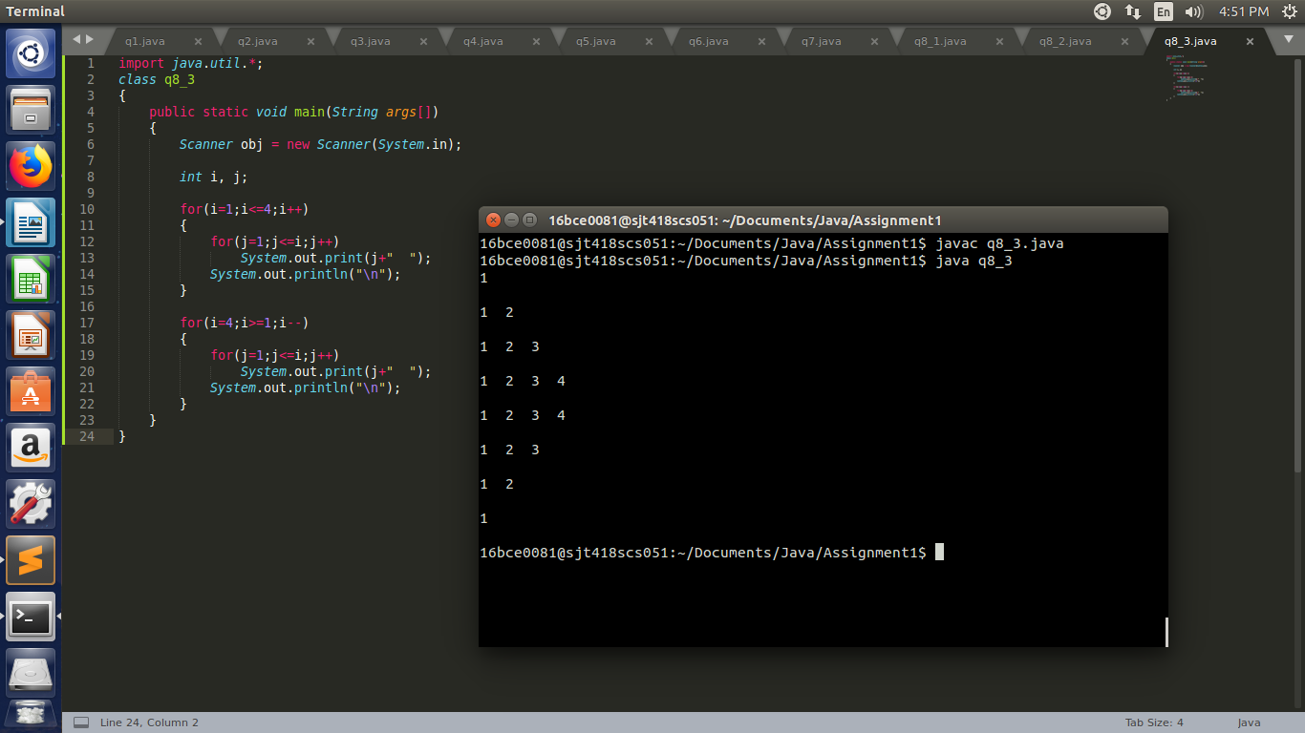

**Experiment – 2**

1. Write a Java program to sort an array of positive integers of an given array, in the sorted array the value of the first element should be maximum, second value should be minimum value, third should be second maximum, fourth second be second minimum and so on.

import java.util.*;

class q1

{

public static void main(String args[])

{

Scanner obj = new Scanner(System.in);

int i, j;

System.out.println("Enter Number of elements");

int n = obj.nextInt();

int a[] = new int[n];

for(i=0;i<n;i++)

a[i] = obj.nextInt();

int temp = 0;

for(i=0;i<n-1;i++)

{

for(j=0;j<n-1;j++)

{

if(a[j]<=a[j+1])

{

temp = a[j];

a[j] = a[j+1];

a[j+1] = temp;

}

}

}

System.out.println("\nSorted Array.");

for(i=0;i<n;i++)

System.out.print(a[i]+" ");

System.out.println("\n\n");

int b[] = new int[n];

for(i=0;i<n;i++)

b[i] = a[n-i-1];

int c[] = new int[n];

j = 0;

int k=0;

for(i=0;i<n;i++)

{

if(i%2==0)

{

c[i] = a[j];

j++;

}

else

{

c[i] = b[k];

k++;

}

}

System.out.println("\nSorted Array in which first element should be maximum, second value should be minimum value, third should be second maximum, fourth second be second minimum and so on.");

for(i=0;i<n;i++)

System.out.print(c[i]+" ");

System.out.println("\n\n");

}

}

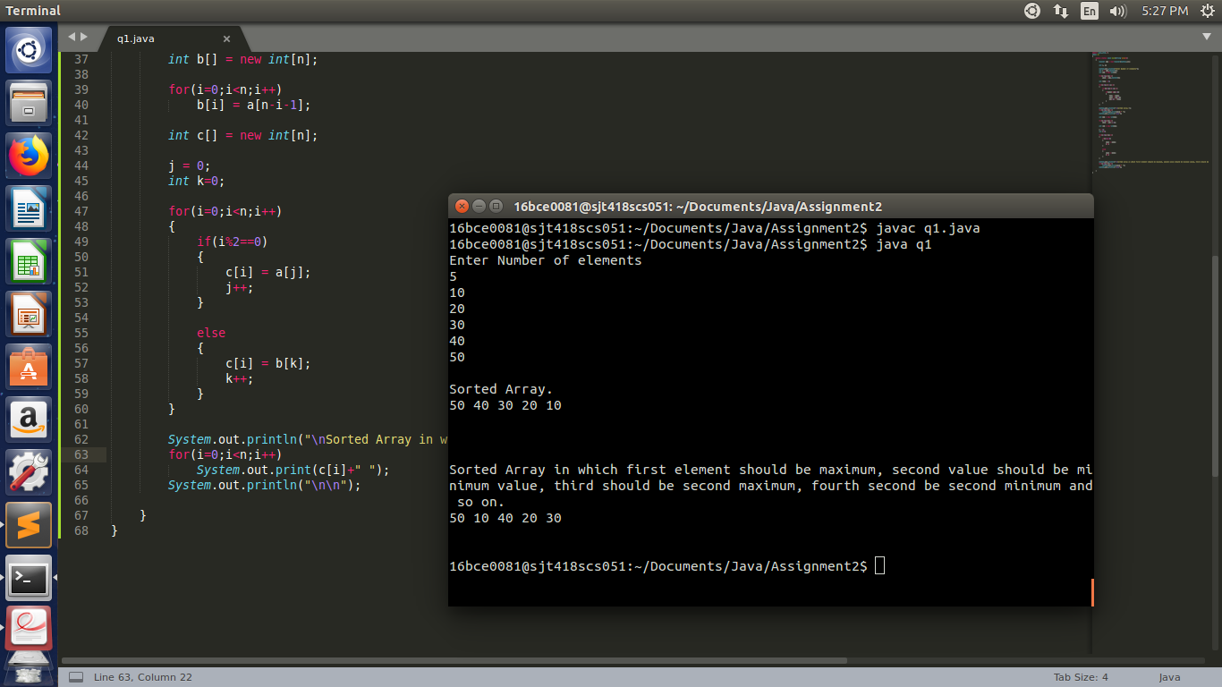

1. Write a Java program to separate even and odd numbers of an given array of integers. Put all even numbers first, and then odd numbers.

import java.util.*;

class q2

{

public static void main(String[] args) {

Scanner obj = new Scanner(System.in);

int num = 0;

System.out.println("Enter the number of elements in the array.");

int n = obj.nextInt();

int a[] = new int[n];

int b[] = new int[n];

int i;

for(i=0;i<n;i++)

{

System.out.println("Enter a number.");

num = obj.nextInt();

}

for(i=0;i<n;i++)

{

if(a[i]%2==0)

b[i] = a[i];

else

b[n-i-1] = a[i];

}

System.out.println("\n");

System.out.println("The modified array is as follows:-\n\n");

for(i=0;i<n;i++)

System.out.print(b[i]+" ");

System.out.println();

}

}

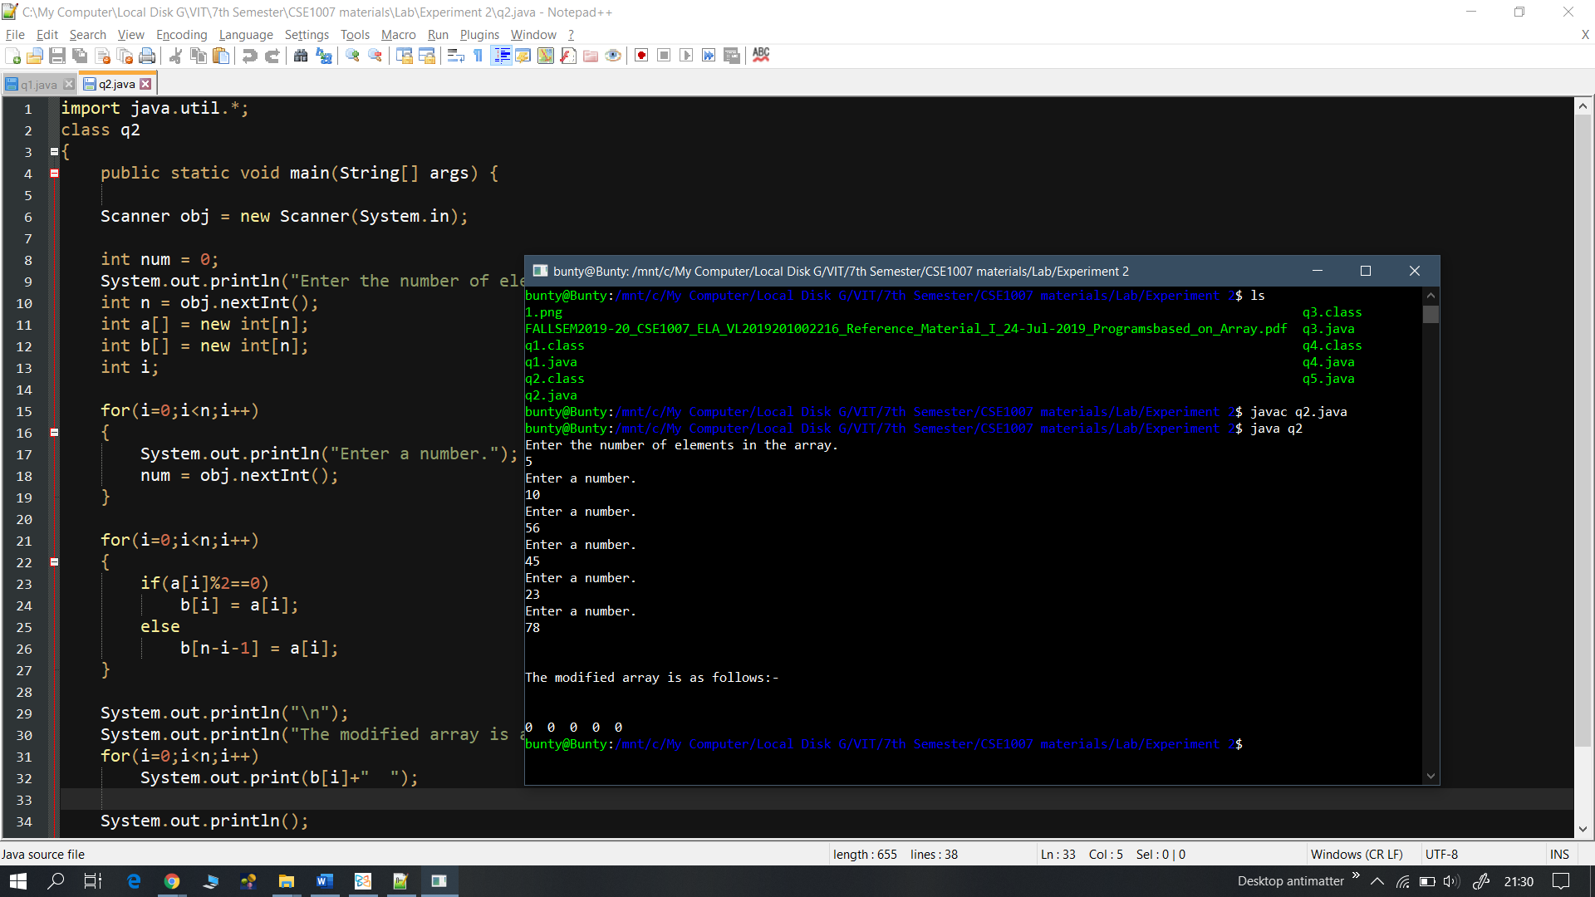

1. Write a Java program to remove the duplicate elements of a given array and return the new length of the array.

import java.util.*;

class q3

{

public static void main(String[] args) {

Scanner obj = new Scanner(System.in);

System.out.println("Enter number of array elements.");

int n = obj.nextInt();

int i, j;

int a[] = new int[n];

for(i=0;i<n;i++)

{

System.out.println("Enter a number.");

a[i] = obj.nextInt();

}

int temp = 0;

for(i=0;i<n;i++)

{

for(j=0;j<n-1;j++)

{

if(a[j]>=a[j+1])

{

temp = a[j];

a[j] = a[j+1];

a[j+1] = temp;

}

}

}

int count=0, l = 0;

for(i=0;i<n-1;i++)

{

if(a[i]==a[i+1])

{

count++;

}

else

l++;

}

System.out.println("\nLength of new array = "+l);

}

}

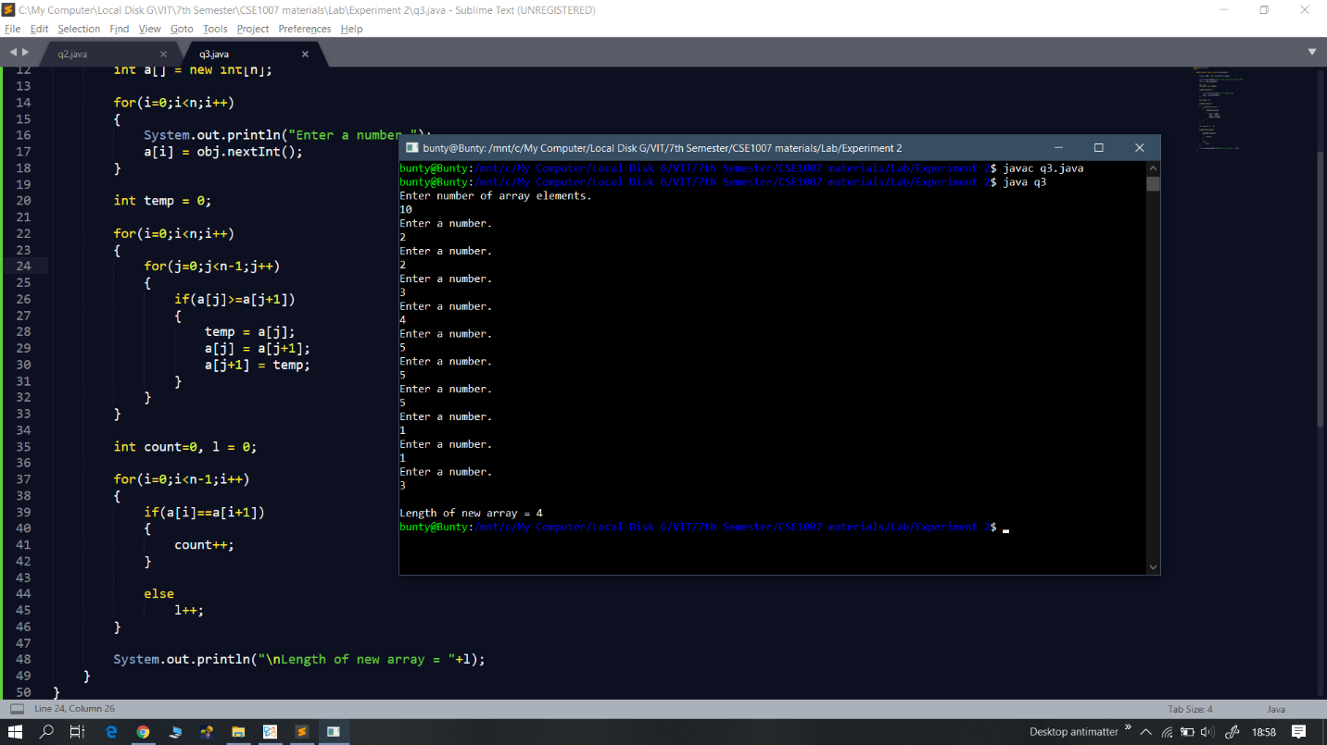

1. Write a Java program to find the sum of the two elements of a given array which is equal to a given integer.

import java.util.*;

class q4

{

public static void main(String[] args) {

Scanner obj = new Scanner(System.in);

System.out.println("Enter the number whose sum is to found from 2 array elements.");

int num = obj.nextInt();

System.out.println("Enter the number of array elements.");

int n = obj.nextInt();

int a[] = new int[n];

int i, j;

for(i=0;i<n;i++)

{

System.out.println("Enter a number. (Preferably less than "+num+")");

a[i] = obj.nextInt();

}

for(i=0;i<n;i++)

{

for(j=i;j<n;j++)

{

if(a[i]+a[j]==num)

System.out.println(a[i]+" + "+a[j]+" = "+num);

}

}

}

}

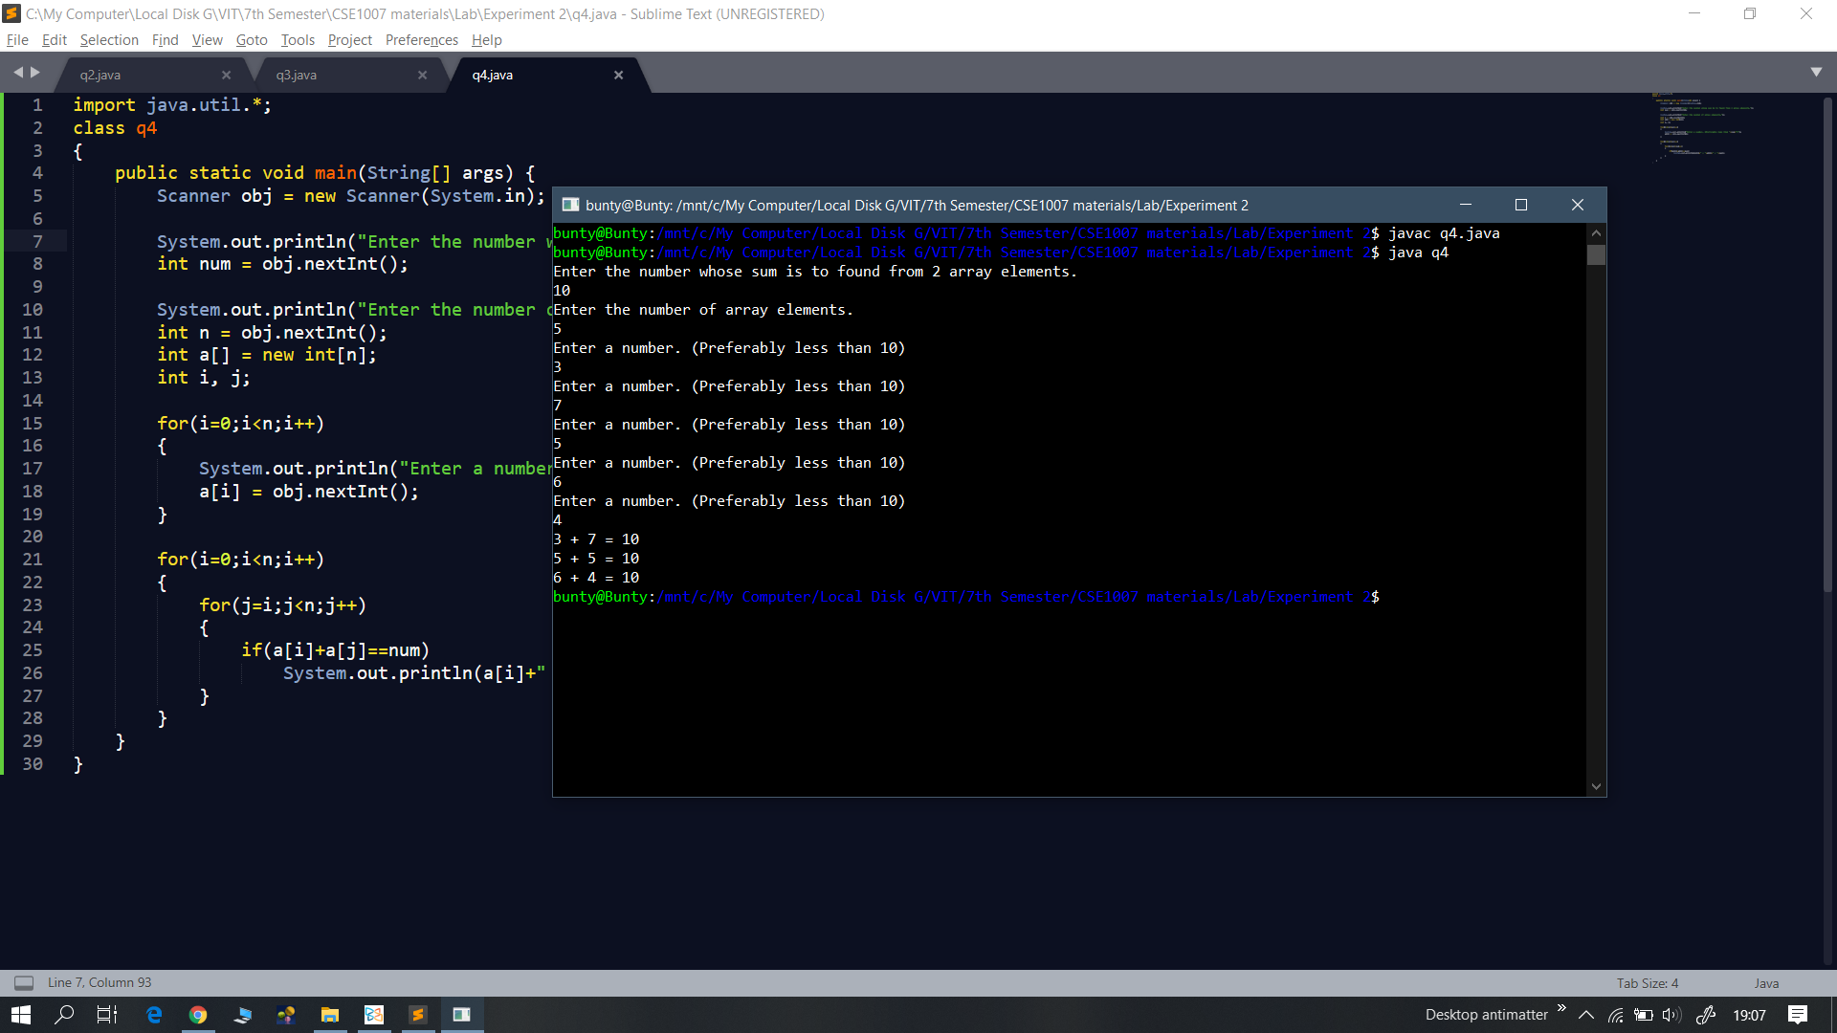

**Experiment – 3**

1. A hash algorithm uses rotation and fold shift methods to compute the address at which the user input has to be stored. Define a static method to perform rotation of the data by moving the least significant digit to the most significant bit position. Also define a non-static method to perform fold shift by dividing the rotated data into segments of length 2 and then add all the segments to get the hash address. If the sum has more than 2 digits, delete the most significant digit and the resulting number is the address. Invoke these methods from main( ) method.

Eg., If the data is 112286, after rotation it should be 611228 and after fold shift it should be 61 + 12 + 28=101 =01 (after deleting the most significant digit)

import java.util.*;

import java.lang.*;

class q1

{

public static void main(String[] args) {

Scanner obj = new Scanner(System.in);

q1 q = new q1();

System.out.println("Enter the address on which calculation has to be done.");

String address = obj.next();

String returened_string = rotate(address);

System.out.println(returened_string);

int get_address = q.segement_add(returened_string);

if(get_address<10)

System.out.println("\nAddress required = 0"+get_address);

else

System.out.println("\nAddress required = "+get_address);

}

static String rotate(String a)

{

int len = a.length();

String sub1 = a.substring(0, len-1);

String sub2 = a.substring(len-1);

String new_string = sub2 + sub1;

return new_string;

}

int segement_add(String a)

{

int l = a.length();

int no_of_segments = l/2;

int segments_array[] = new int[no_of_segments];

int i, j=0;

int sum = 0;

for(i=0;i<l;i=i+2)

{

String extracted_substring = a.substring(i, i+2);

segments_array[j] = Integer.parseInt(extracted_substring);

System.out.print(segments_array[j]+" ");

j++;

}

for(i=0;i<no_of_segments;i++)

{

sum = sum + segments_array[i];

}

return sum%100;

}

}

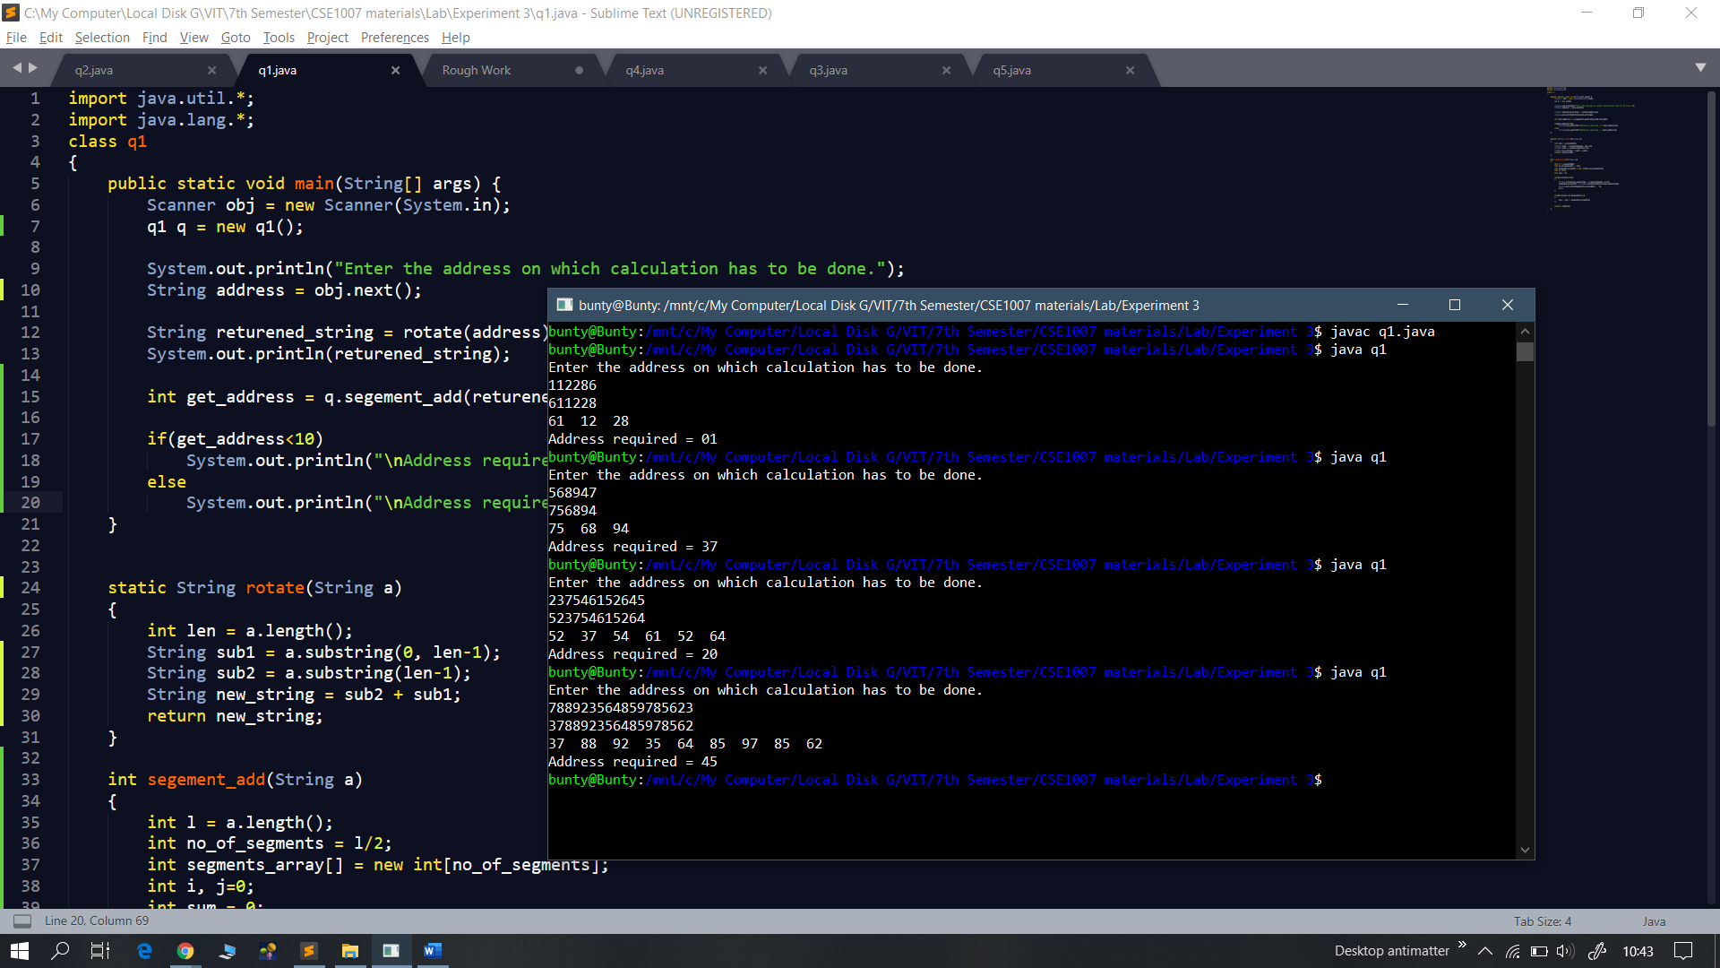

1. Consider a Java program containing a statement to invoke format( ) method for displaying the output. Write a program to verify the syntax correctness of the statement by checking for the following.

The number of format specifiers and arguments should match.

Datatype of the arguments should match the format specifiers used.

For example, if the input is similar to any of the three statements given below, the output should be “correct syntax” for the first two statements and it should be “wrong syntax” for the last statement.

System.out.format("sum is %d"+" avg is %f ", a,b);

System.out.format(" name is %s"+"sum is %d avg is %f ", s,a,b);

System.out.format("sum is %d"+" avg is %f ", b,a);

Assume you have a 2D String array storing all the variables used in the program and their datatypes as follows.

|  |  |  |  |
| --- | --- | --- | --- |
| a | B | s | x |
| int | Float | String | int |

import java.util.*;

class q2

{

public static void main(String[] args) {

q2 q = new q2();

Scanner obj = new Scanner(System.in);

String a[][] = {{"a", "b", "s", "x"}, {"int", "float", "String", "int"}};

System.out.println("Enter the statement. ");

String text = obj.next();

q.format(text);

}

void format(String input)

{

int i, j=0, k=0;

int len = input.length();

int index_format[] = new int[4];

int index_comma[] = new int[4];

char ch = ' ';

for(i=0;i<len;i++)

{

ch = input.charAt(i);

if(ch=='%')

{

index_format[j] = i + 1;

j++;

}

if(ch==',')

{

index_comma[k] = i + 1;

k++;

}

}

for(i=0;i<4;i++)

{

if((input.charAt(index_format[i])=='d') && (input.charAt(index_comma[i]=='a')))

System.out.println("Syntax is correct");

else if((input.charAt(index_format[i])=='f') && (input.charAt(index_comma[i]=='b')))

System.out.println("Syntax is correct");

else if((input.charAt(index_format[i])=='s') && (input.charAt(index_comma[i]=='s')))

System.out.println("Syntax is correct");

else if((input.charAt(index_format[i])=='d') && (input.charAt(index_comma[i]=='x')))

System.out.println("Syntax is correct");

else

System.out.println("Syntax is wrong!");

}

}

}

